Welcome! Glad you’re here. It’s Awesome. Let’s get to know each other, get to know our Catholic faith a little better…oh, and have fun!
Here’s the 2017-2018 year, followed by a general idea of the topic o’ the day:
Sunday, Sept. 17th- Open House…meet in Feist Hall, then head over to the Convent and have some donuts
Sunday, Sept.24 ^{th}- Regular meeting (from now on meet in the Convent after youth sign in with RE @ front office)
Sunday, Oct. 1st – Join us as we serve coffee and donuts after the 10am Mass (this is to help with the Baby Shower supporting Guadelupe Maternity Center), after which we will move to the Convent and continue our meeting (Topic: Serving God in our community)
Sunday, Oct. 8th – Regular meeting (Topic: Jesus)
Friday, Oct. 13th – Rosary in church at 7pm followed by a Special Movie in Convent Building. (This is the 100th Anniversary of the “Miracle of the Sun” at Fatima. Join us in our Prayer for Peace.)
Sunday, Oct.15 ^{th} – Regular meeting (Topic: Jesus and The Sacraments)
Sunday, Oct. 22nd – Regular meeting (Topic: The Mass and The Eucharist)
Sunday, Oct. 29th – Regular meeting (Topic: The Mass and The Eucharist)
Sunday, Nov.5th – Regular meeting (Topic: The Mass and The Eucharist)
Sunday, Nov. 12th – Regular meeting (Topic: The Mass and The Eucharist)
Sunday, Nov. 26th – NO MEETING…Enjoy some leftover turkey with family…Gobble Gobble
Saturday, Dec. 2nd Join us for a NET retreat at St. Pat’s Don’t Miss This!!!
Sunday, Dec. 3rd Advent Festival…Sign up and volunteer! We need you!
Sunday, Dec. 10th- Regular meeting (Topic: Jesus)
Sunday, Dec. 17th – Regular meeting (Rel. Ed. Christmas Program)
Ho Ho Ho! Merry Christmas and Happy New Year!
Schedule for 2016
Sunday, Jan. 7^{th,} – Regular meeting (Topic: Review)
Sunday, Jan. 15th – NO MEETING…Do something kind for someone else today!
Sunday, Jan. 21st Regular meeting (Topic: Social Teachings of The Church)
Consider joining us at The March for Life in Olympia. Monday January 22nd St. Charles bus departs at 8am from church parking lot.
Sunday, Jan. 28th – Regular meeting (Topic: Social Teachings of The Church)
Saturday Feb.3rd and Sunday, Feb. 4th – Souper Bowl after ALL MASSES Regular meeting @ 11:15 in Convent (Topic: Morality and Living a Virtuous Life)
NO MEETING Feb. 11th – Religious Art Festival : Sign up to volunteer and score some bonus points with Jesus.
Sunday, Feb. 18th – NO MEETING…Pray a rosary for unity and peace in our world today!
Sunday, Feb. 25th – Regular meeting (Topic: Morality and Living a Virtuous Life)
Sunday, March 4th – Regular meeting (Topic: Morality and Living a Virtuous Life)
Saturday March 10th – Archdiocesan Jr. High Youth Rally @ Forest Ridge School of the Sacred Heart in Bellevue
Sunday, March 11th – Regular meeting (Topic: Morality and Living a Virtuous Life)
Sunday, March 18th – Regular meeting (Topic: TBD)
Sunday, March 25th – SPRING BREAK- NO MEETING
Sunday, April 1st –Easter Sunday NO MEETING He is risen! Be amazed at His Awesomeness
Sunday, April 8th – Regular meeting (Topic: TBD)
Sunday, April 15th – Last regular meeting (Topic: TBD)
Sunday, April 22nd -- A FULL DAY OF EXTREME AWESOME
Sunday, April 29th – Closing Celebration for Religious Ed. (after 10am Family Mass)
*************AND THAT”S A WRAP! ENJOY YOUR SUMMER!*****************
For the Ultimate Awesome, Join us Summer 2018, A Mission Trip with Charlie’s Heroes:
Ft. Steilacoom Park August 10th, 11th and 12th.
Interested? Ask me. I’ll tell you all about it. Or go to www.The3004US.org
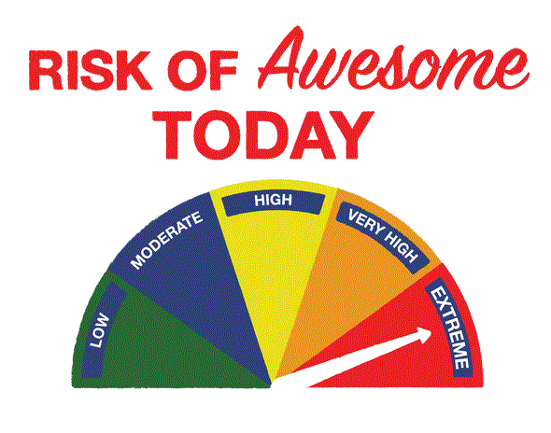
Q: Okay, so thanks for the dates…but, (yawn) like, what will we be doing?
A: Besides chowing down some donuts (come an’ get ‘em, FRESH every Sunday) and hanging out, we will also be exploring our Super-Mega-Awesome Catholic faith.
The BURNING HOT topics of our year:
God: How do I know He is real and that He cares about me? How can I experience His Awesomeness?
Mass: Why do I have to go? What am I supposed to get out of it?
Jesus: Yah, that guy. I know about Him, but do I really know Him? How can I get to know Him better?
Prayer: Why should I pray? How do I make time to pray and make it meaningful? What is the point of memorizing the prayers of my faith? And what’s with that Rosary?
Sacraments: What are they? Why are they important to me?
Relationships: Why are relationships with family and friends important? What does that have to do with my faith and my relationship and understanding of God, Jesus and the Holy Spirit?
Morality: What is my moral compass? What direction are my decisions taking me? How the heck am I supposed to live a virtuous life? What does that mean, anyways?
Social teachings: Why should I care about other people? What does the church expect someone my age to do about poverty, injustice, and other problems in the world?
Christianity: Why do so many people follow Jesus? Is a Catholic a Christian too? Is there a difference? How does Christianity relate to other world religions? Can I defend my faith?
Vocations: How do I know God’s plan for my life? What are my options? How do I choose?

Welcome to JR HIGH YOUTH GROUP!

Students:
Please fill out a “Who Am I?” index card.
On each card list 3 interesting things about yourself.
Examples: Number of siblings, pets, where you went this summer, favorite things (movies/books/video games)
DO NOT put your name on the card.
When complete, place upside down in front of you on the table.
Fill out a Parent/Youth Survey.

Parents:
Please take a schedule for the year.
Please take a moment to fill out the parent survey.
Let me know if you have any questions, or feel free to email me. Thanks!

